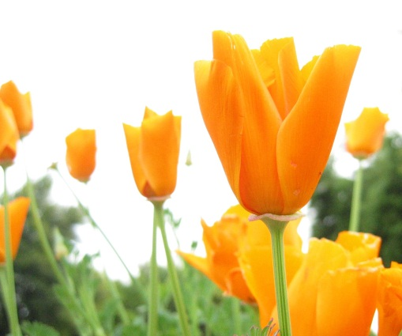
PERSONAL ENRICHMENT
Spring 2014

Arts & Crafts

Taking Watercolor Lightly
Class will include various demonstrations of watercolor techniques along a central subject. Subject matter is determined by the individual desires of students. Personal instruction and critique of work through to completed artwork. Intended to encourage students to think about subject being painted and challenge each artist to explore the full potential that watercolor can offer as a media with a majority of the class devoted to painting. Please contact Nikki Sanders at 919-464-2421 for a supply list.

Course Code: CSP 4000 12p
Date: January 14-March 18 T
Time: 9a-12noon
Location: Cleveland Center
Fee: $95

Course Code: CSP 4000 13p
Date: January 21-March 25 T
Time: 1-4pm
Location: Cleveland Center
Fee: $95

Quilting Basics
Discover the art of quilting. This class is for the beginner. You will learn how to use a sewing machine, fabric selections, rotary cutting, piecing and quilting techniques. Please contact Nikki Sanders at 919-464-2421 for a supply list.

Course Code: CSP 4000 15p
Date: January 20-March 24 M
Time: 1:30-4:30pm
Location: JCC/Sanders Bldg (Sewing Lab)
Fee: $95

Quilting
This class is for those of you with sewing machine experience. We will be making a quilt from start to finish. We will reinforce rotary cutting, fabric selection, quilting techniques, mastering the quarter inch seams, pressing and using the right tools. Please contact Nikki Sanders at 919-464-2421 for a supply list.

Course Code: CSP 4000 14p
Date: January 20-March 24 M
Time: 9a-1p
Location: JCC/Sanders Bldg (Sewing Lab)
Fee: $130
Prerequisite: Quilting Basics recommended by not required.

Beginning Knitting
Looking to pick up a new hobby in 2014? Why not try knitting! In this knitting class for absolute beginners, students will learn how to pick yarn, read a yarn label, plan a project, take gauge, cast on stitches, the knit stitch, the purl stitch, and how to fix common mistakes. Please contact Nikki Sanders at 919-464-2421 for a supply list.

Course Code: CSP 4000 22P
Date: February 3-February 17 M
Times: 6:00-8:00pm
Location: Cleveland Center
Fee: $30

Intermediate Knitting
Continue to expand upon your acquired knitting skills in this intermediate knitting class. While beginning knitting is not a prerequisite, anyone enrolling in this course should already have some basic knitting skills. Please contact Nikki Sanders at 919-464-2421 for a supply list.

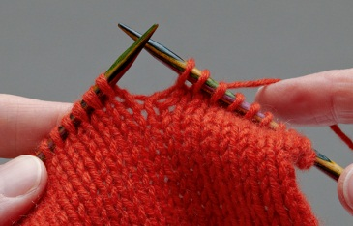
Course Code: CSP 4000 23P
Date: February 24-March 10 M
Times: 6:00-8:00pm
Location: Cleveland Center
Fee: $30

Advanced Knitting
Enjoy knitting? This advanced class will teach you some new knitting techniques as well as introduce you to working with more challenging yarns and patterns. Previous knitting experience is required. Beginners knitting and intermediate knitting are recommended courses. Please contact Nikki Sanders at 919-464-2421 for a supply list.

Course Code: CSP 4000 24P
Date: March 17-March 31 M
Times: 6:00-8:00pm
Location: Cleveland Center
Fee: $30

Beginning Crochet
Discover the art of crochet for yourself, or to create homemade gifts for friends and family. This beginners course will introduce you to reading a yarn label, reading patterns, starting your project, and some of the more basic crochet stitches. Please contact Nikki Sanders at 919-464-2421 for a supply list.

Course Code: CSP 4000 25p
Date: February 5-February 17 W
Times: 10a-12noon
Location: Cleveland Center
Fee: $30

Intermediate Crochet
Continue to expand upon your acquired crochet skills in this intermediate crochet class. While beginning crochet is not a prerequisite, anyone enrolling in this course should already have some basic crochet skills. Please contact Nikki Sanders at 919-464-2421 for a supply list.

Course Code: CSP 4000 26p
Date: February 26-March 12 W
Times: 10a-12noon
Location: Cleveland Center
Fee: $30

Advanced Crochet
Enjoy crocheting? This advanced class will teach you some new crochet techniques as well as introduce you to working with more challenging yarns and patterns. Previous crochet experience is required. Beginners crochet and intermediate crochet are recommended courses. Please contact Nikki Sanders at 919-464-2421 for a supply list.

Course Code: CSP 4000 27p
Date: March 19-April 2 W
Times: 10a-12noon
Location: Cleveland Center
Fee: $30

Jewelry Making
Learn the art of jewelry making using a torch. Projects will include fabricating plain and stone set rings and pendants as well as creating earrings. Acid etching will also be introduced. Techniques will include basic design, soldering, sawing, filing, drilling, stone setting, forming and polishing. Tools will be provided. A $40 materials fee must be paid to the instructor on the first day of class.

Course Code: CSP 4000 21p
Date: March 11-April 29 T
Times: 6:00-8:30pm
Location: Main Campus-Graphic Arts B102
Fee: $60

Culinary Arts

Cooking, Canning, and Storing
Create a variety of kitchen goodies that you can enjoy immediately, or keep in your cupboard for a rainy day. Everything from soups to preserves, to common fruits and vegetables will be prepared and preserved in this fun, and informative class. Students will learn proper methods to store items grown in the garden or purchased in bulk at farmer's markets or fruit stands. Sanitation standards, shelf life, and the costs of using various techniques for food preservation and storing will be introduced.

Course Code: CSP 4000 33p
Date: April 12 Saturday
Time: 9a-12:30pm
Location: Cleveland Center
Fee: $20

Healthy Eating
What better way to start off the new year and keep your New Year’s resolution of getting in shape than by learning about healthy foods and how to prepare them from award-winning Chef Brian.

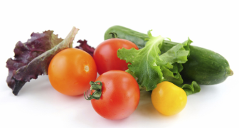
Course Code: CSP 4000 28p
Date: January 23 Th
Times: 6:00-8:30pm
Location: Cleveland Center
Fee: $25

Cooking Comfort Foods
Chef Brian is making comfort foods with a twist. While the weather is still cool, learn how to heat up your home with the warmth and aromas of comfort foods that everyone is sure to enjoy.

Course Code: CSP 4000 29p
Date: February 6 Th
Times: 6:00-8:30pm
Location: Cleveland Center
Fee: $25

Romantic Hors D ’Oeuvres & Small Plates for Valentine’s Day
Learn to create special dishes to impress your Valentine this year. Better yet, what a perfect way to celebrate the holiday than taking a fun and informative cooking class with the one you love! Either way, these simple but elegant small plates will entice you and your special Valentine.

Course Code: CSP 4000 30p
Date: February 13 Th
Times: 6:00-8:30pm
Location: Cleveland Center
Fee: $25

Mother’s Day Tea Party
What better way to show Mom how much you care than spending some quality time together in the kitchen. Our kitchen, that is! Learn to make some delicious baked goods, discuss “tablescapes” for the perfect tea party, and finally, relax with Mom and enjoy the fruits of your labor at an authentic tea party to celebrate that special lady on her special day.

Course Code: CSP 4000 19p
Date: May 8 Th
Times: 6:00-8:00pm
Location: Cleveland Center
Fee: $20

Healthy Living

Yoga Basics
This introduction to yoga includes basic postures, breathing, and meditation. Emphasis is placed on working with the body safely to promote strength and well-being while still gaining physical progress toward traditional postures. Students must bring their own a yoga mat.

Course Code: CSP 4000 16p
Date: January 13-March 3 M
Times: 6:30-7:30pm
Location: Cleveland Center
Fee: $80

Course Code: CSP 4000 36p
Date: March 10-May5 M (no class 3/21)
Times: 6:30-7:30pm
Location: Cleveland Center
Fee: $80

Massage Techniques for Everyone
Massage is a great way to relieve muscle aches and pains, increase flexibility, decrease the chance of injury, and offer stress relief. In this class, you will learn simple but effective massage techniques that you can use on yourself, or your family and friends. This is a great opportunity for parents with children who participate in sports to be able to offer stretching and massage to help improve performance and prevent muscle strain. This class is designed for anyone wishing to learn basic massage techniques, who is not a licensed massage therapist. This class is NOT designed to teach you how to be a massage therapist, but can be taken by someone who is interested in exploring the field of massage. Pre-registration is required.

Course Code: CSP 4000 32p
Dates/Days: March 6, 2014 – March 13, 2014 (Th)
Course Times: 6:00 p.m. - 8:00 p.m.
Location: Main Campus
Registration Fee: $20.00

Personal Finance and Computer Basics

Computer Basics for Seniors
This course is introductory and designed for seniors who are looking to gain some experience with the internet. This class will introduce e-mail, and applications like Facebook that can be used to keep up with the Grandkids.

Course Code: CSP 4000 20p
Date: March 6-March 27 Th
Course Times: 9a-12noon
Location: Kenly Center
Fee: $40

Working With Your Holiday Photos
Using a computer, participants will learn how to take their digital photos and create online albums, or save photos to a flash drive for later printing. Applications for storing and sharing photos, such as Picasa and Photobucket will be introduced.

Course Code: CSP 4000 17p
Date: February 4-February 25 T
Course Times: 9a-12noon
Location: Kenly Center
Registration Fee: $40

Using Excel To Balance Your Checkbook
Balancing your checkbook and budget can be a real chore. In this introductory class, you will learn how Microsoft Excel can do the work for you so you never bounce a check again!

Course Code: CSP 4000 18p
Date: April 1-April 22 T
Course Times: 6pm-9pm
Location: Kenly Center
Fee: $40

Technology For The Rest Of Us
Need some help using those new gadgets you got this Christmas? This slow-paced survey of existing and emerging personal communication, entertainment, and information devices will take the guesswork out of that new technology. Topics include iPhones, Smart phones, Kindles, basic cell phones, eBooks, and laptops. Software applications and consumer operating plans will be covered.

Course Code: CSP 4000 31p
Date: January 28 – February 4 T
Course Times: 9a-12noon
Location: Workforce Development Center
Fee: $15

Understanding Insurance
Confused about insurance? Don’t know what to get, or how much you need? Do you know the different types available, and what they can do to benefit you? Join us to learn all about insurance, how to make it work for you, and how to get it for the cheapest prices.

Course Code: CSP 4000 34p
Date: March 17 M
Course Times: 6p-8p
Location: Benson Conference Center
Fee: $10

Course Code: CSP 4000 35p
Date: April 7 M
Course Times: 6p-8p
Location: Workforce Development Center
Fee: $10

